21 August 2020

Dear Parent/Carer

SIMs Pay - Cashless Payments and Catering

As we approach the start of the new academic term, I am keen to keep you informed regarding all the necessary information you will require for your child to start their new year smoothly. Due to the current measures that we need to implement due to Covid-19, we are going to be changing the way all students are able to make payments onto their SIMs Pay accounts. From September, all payments will be expected to be made online via your child’s SIMs Pay account, therefore students will no longer be able to pay cash via the reval machine in Student Reception.

It is therefore vital that parents/carers have set up their online payment system and have made sure their child/children have adequate credit in their accounts for the beginning of term. Further information regarding this system can be found on the Priory Ruskin Homepage, Parents, Cashless Catering or by following this link: https://www.prioryruskin.co.uk/page/?title=Cashless+Catering&pid=150. Please reply directly to this email or contact the Academy if you require the activation code to enable you to set this up.

Again, due to the complexities of having students being catered for in several different areas and over a longer period of time for lunch we have had to reduce the menu we offer students currently. We would like to encourage as many students as possible to bring a packed lunch to ease this situation where possible.

Another measure that we have had to take due to the current Covid situation is that students will not be using the finger print scanner to make payment for meals but will be given a 4 digit PIN code which they will use instead to identify their account. This code will be given to each child at the beginning of the new term.

We look forward to welcoming all students back in September, however in the meantime if you have any other queries please email generalenquiries@prioryruskin.co.uk and we will get back to you.

Yours sincerely
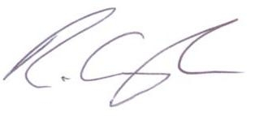
Mr R Gough
Associate Assistant Headteacher

