

Wellbeing Guide
For Your Physical and
Mental Health

Advice and guidance for students during the coronavirus lockdown

“ The virus doesn’t move, people move it. We stop moving, the virus dies.”

Stay at home


As you know, we are in the middle of the coronavirus Covid 19 pandemic affecting the whole world.
In a crisis like this as humans we start doing weird things. Like buying too much toilet roll and pasta, or staying up late reading the news, arguing more, struggling to sleep, being teary, feeling overwhelmed, headaches, ranting, picking fights, getting into arguments and that is just the adults !
If you are feeling any of these things, I have good news. You are 100% not alone. You are in fact completely normal, a fully functional human being. We are all living in extremely anxious times, it is scary and it makes can make us feel out of control, and this on top of everything else we have going on.
So here is a little bit of science…
When we are exposed to a threat our brain springs into action. Specifically a bit of your brain buried behind your ear called the amygdale. This is the bit in our brain that is in charge when we are frightened. Right now for many people this bit of our brain is working overtime. People react in different ways.
Maybe through physical signs, stomach upsets, headaches, insomnia, changes to eating, changes to the way we talk. We can become bad at making decisions, absorbing information and generally thinking rationally.
So when we are scared, or under pressure and starting to feel anxious we need to take control.
So it is hoped that the information in this guide will help you to take control of your mental and physical health over the coming weeks as we stay in our homes and do the very best that we can to continue looking after one another.


Talk to your family and make sure you know the answer to all of these questions.
- How should you deal with a healthcare emergency?
- Who should you phone in your family / friends?
- Do you know the signs for a fever, dehydration and coronavirus?
- Do you know how to help someone with a fever, whilst making sure that you stay safe?
- How can you help you family with cleaning? What cleaning products should you use?
- Do you know when to phone an ambulance?
- Do you know your address and date of births of all of family members?
- Have you talked through with my family what to do in different situations?



Having more time to think can mean that you find yourself falling into a downward spiral, particularly given these challenging times. Keep yourself distracted by ‘doing’ rather than ‘thinking’.
Give yourself a purpose every day and think positively about what you can control.

I will self-isolate and wash my hands and significantly decrease my chances of getting sick.
We don’t have any pasta!
I’m bored
I get to be safe in my home and spend time with my family.
I’m stuck at home

I will get sick

Important places like food shops and pharmacies remain open.
Everything is shutting down.

We have flour and water, we can make some pasta.

There are other ways I can communicate with friends & family
I can’t see my friends and family

There is so much my family and I can do now we have time

I can’t control the situation around me BUT I can control my actions. Completing my school work, helping at home, looking after loved ones, keeping busy, and saying prayers can help
There is too much uncertainty right now



We are all very used to our routine of going to school Monday to Friday. Getting up, putting on school uniform and making the journey to school. Once at school we follow a timetable for our lessons. We are very used to a routine.
Now that we are learning from home, it is important to create a new routine for the days when we would be school. Without this it would be easy to get up late every day and stay in our pyjamas, but this is really not good for our mental or physical health.
It is also too easy to forget about the simplest things like personal hygiene. Don’t do this, get up, get washed, clean teeth, brush hair as normal.


- Monday-Friday get up early, wash, dress, clean teeth, do hair, eat breakfast.
- Plan a daily routine with your family, for example who uses the computer when?
- Look at SMHW and plan the day. Which lessons do you have? What learning have you been set? Think about the order to complete in to ensure you get breaks from the screen and ensure all family member computer needs are met.
- Remember to include rest breaks and lunch break into your plan.
- Consider building in time for quiet calm and reflection.
- Build your social media time into your plan but switch your phone off whilst completing school work. You know this makes sense. Reward yourself once you have completed your work
- Don’t forget to include household chores into your daily plan. This will give you a break from the screen, give you some physical exercise and help to reduce stress and tension for the whole family. Ask what you can do to help.
- Don’t forget to include some physical activity into your daily routine


Without our normal routine of going to school our sense of time will change. Our days will be spent without the teachers telling us to pack up our things and head off to our next lesson.
The physical spaces we exist in will change, no buses, no trains, no school playground, no classrooms, or canteen. Our space will become so much smaller. This is a challenging situation for everybody. However we must stay in our own homes to control the spread of the virus. Remember that this is temporary.
We will find ourselves in a smaller space for longer periods of time with the same people.
It doesn’t matter how much you love each, when you spend all your time together in the same space it can create stress and tension.


- Having a household routine is so important, think about where and how you will spend your time at home. Plan how you and other family members will use the time and space. Maybe you have siblings, parents or carers who may also need to use the computer. Give everyone a say, discuss it, plan it and avoid arguments which can easily arise in these situations.
- Consider talking to your family about what life might be like for the next few weeks and how you will all behave towards one another. Do you think you need to identify a space and a time for you to be on your own (and all of your family members too!) If this is important to you then discuss the importance of this. Think about what the clues in our behaviour indicate that we feel stressed or frustrated?
- Think about how you can help in situations when family become stressed. Consider these questions if this does happen. What happened? What were they thinking at the time? Is there anything that you can do to make things right?
- We will all notice that time will slow down, we will not be rushing around. Can you use this valuable time to learn something new? What will you gain from this period of isolation at home.
- Try to respect each other’s privacy and give each other space.
- When things start to feel tense, take a deep breath, go to another room and try to calm yourself before things escalate.
- Come together for reflection
If you feel trapped
- Open the windows to let in fresh air. Or you could spend time sitting on your doorstep, or in the garden if you have one.
- Try looking at the sky out of the window or from your doorstep. This can help to give you a sense of space.
- Regularly change the rooms you spend time in.


Completing school work
Being out of school will make it so much likely that we will spend more time on technology and social media.
After all we will be relying on technology for you to complete your school work. You will be spending more time working at a screen than usual.
Spending prolonged periods of time looking at a screen is not good for you. It can create strain on your eyes, over stimulate the brain, disrupt sleep and is usually linked with a lack of movement.

Try to plan you day so that you have breaks from the screen.
Get up and more around, change position.
Make a list of the learning tasks from school and consider the best order to complete them in. If you have task that does not rely on technology consider doing that in between tasks that need to be completed on the computer.
Plan with family members who will use the computer and when to avoid stress building up.
To produce the best wok that you are capable of you know that it makes sense to……..
turn your phone off!

Social media
Social media has lots of benefits, particularly in the current situation it will help us to stay connected.
Do remember that social distancing is not the same as social isolation, it is still important to communicate with friends and family.
It is important to stay connected and social media can be a great form of communication but be aware some types of social media carry more risks than others for your wellbeing.
Youtube in particular has been found to be very effective in decreasing levels of depression, anxiety and loneliness and of course is a great source of information when trying to learn something new.
Despite all the benefits of social media, the absolute truth from all the research undertaken is the more someone spends online on social media, the greater the likelihood of potential harm.
ALL types of social media have been found to have a negative effect on sleep quality, body image, bullying and FOMO (fear of missing out)
Snapchat, Instagram have been found to have a hugely negative impact on wellbeing.
In this time of pandemic crisis we are all (young people and adults) more vulnerable to the potential harm.


- Turn it OFF while you are working
- Don’t give in to the pressure to be constantly connected at the expense of other activities. We have been gifted with time to spend as a family. Use this precious opportunity that when life returns to normal we will all wish we had.
- Be aware of FAKE NEWS stories, there are lots of them going around at the moment.
- Stay safe online.
- Don’t allow social media to undermine your view of yourself. Most of what you see and read is simply not real.



Exercise
The challenge of getting enough exercise will be felt by everyone whilst we are being asked to stay at home.
No more walking up that hill to school or all those stairs to the Kickout to use computers or walking all the way down to lunch and of course no PE lessons.
Absolute fact - Exercise is essential for our physical and mental health.
Exercise helps to manage worry and releases some of the anxious energy in the body.
Nature is healing, going to your local park or green space and taking a walk is a great way to de-stress.
However we must follow the guidance from the government about being outside at this time.

- Build some activity into your daily routine.
- There are lots of online exercises and workouts
- Jo Wicks the body coach has PE lessons every day at 9.00am
- Yoga is a great form of exercise and will also help with releasing the worry and stress of being isolated at home. There are lots of videos online
- Generally sitting less, if you notice that you have been sitting down for an hour, just get up, walk around and stretch and change positions
- Dancing is great exercise, great fun and has a positive impact on physical and mental health. Get your whole family moving on Tik Tok



Consider creating a pre-sleep routine by turning off news and screens at least an hour before going to bed. If you wake during the night and find you can’t sleep, rather than sit lay there and worry, try a meditation from the ‘Sleep’ program’ in the Smiling Mind App.

Sleep
When we’re fearful and anxious it can be hard to sleep. Given the importance of sleep for our mental and physical wellbeing, including immunity to illness, establishing good habits around sleep is particularly important at the moment.

Priory Ruskin PE at Home

When undertaking exercise and the plans detailed below please ensure that all the latest Government Guidelines are adhered to in full. This is especially important if exercising away from the home.
You don’t need a fitness suite or equipment to train and keep fit. To get fit you just need enthusiasm and a few ideas. The Ruskin PE Department always believe that a challenge and ideas will help, so we thought if people are going to be stuck at home for a period of time why not take on the challenge of seeing how fit you can get.
The challenge is to see how many of the weekly challenges pupils and their families can complete. The weekly challenges will have some variety and also different levelled challenges. Don’t opt for ease and don’t break yourself trying to do too much, choose the distance/activity that will challenge you and you can still move afterwards!
The running challenge is to be performed at the decision of parents/guardians as this does require pupils to go outside. As such pupils must always ask permission from a parent/guardian before going outside, and inform them of where you will be running, stick to paths and safe areas. I would also advise all to download an app called strava which will measure how far you have ran and tell you lots of useful information about your run.



In addition Joe Wicks (youtube) is doing a fitness class each day with live stream at 0930am. This can be watched live on youtube or any time throughout the day. Just go to youtube.com and search Joe Wicks for his latest video each day.

Priory Ruskin No School Week 1 Exercise Challenges
Circuit Training Ses 1 | Running Challenges | Circuit Training Ses 2
Do the following activities with a rep count up to 20, with a 30 second rest between stations. Repeat the circuit up to 5 times. 90 seconds rest between sets. | Remember to ask for permission if going out for run, be safe and stick to paths and safe spaces.  Choose the distance or activity that best suits you. Try to progress this next week. | Do the following activities with a rep count up to 20, with a 30 second rest between stations. Repeat the circuit up to 5 times. 90 seconds rest between sets.
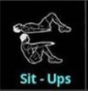 | 1.5km run | 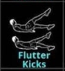
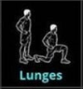 | 2.5 km run | 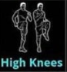
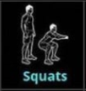 | 4 km run | 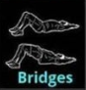
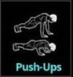 | 5km run | 
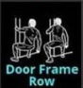 | 7.5km | 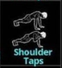
 | 10km | 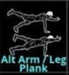


The change in our daily routine and current situation could affect what, when and why we eat.
We all know the problems that the virus has created in food shops and the extra pressure this has put on families seeking food.
Eating regularly and keeping our blood sugar levels stable can help our mood and energy levels.
Drinking enough water is important for your mental and physical health.
You must continue to think about your diet during this period of staying in our homes.
It is common to use food as a comfort when we are feeling sad or stressed.
It is very easy when we are at home all day to snack unnecessarily.
However it is also an opportunity to be together as a family and eating and sharing food is an important family activity.

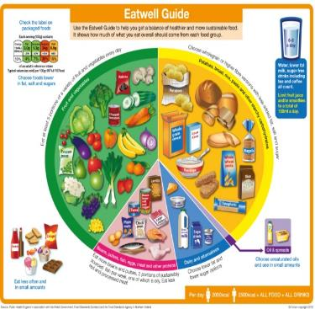

- Try to follow the Eatwell guide and dietary guidelines if you can. Eating fruit and vegetables will strengthen your immune system. Aim for you five portions every day.
- Avoid snacking on foods that are high in fat, sugar and salt particularly because we will be less active.
- Get involved in the kitchen. The extra time we now have at home is a great opportunity to be alongside family members, sharing ideas and preparing food together.
- Be open minded about trying new foods, be experimental. The shortage of food in shops will put pressure on families so don’t add to that by being fussy if you cannot eat the same foods that you would normally have.
- Drink plenty of water.
Our immune system helps us to fight illness and infection. Nutrients that help to build a strong immune system include Vitamin A and Vitamin C.
Vitamin A – Good sources include Liver, cheese, eggs, dark green leafy vegetables and orange-coloured fruits and vegetables (e.g. carrot, sweet potato, butternut squash, cantaloupe melon and papaya).
Vitamin C – Good sources include - Fruit (especially citrus fruits, blackcurrants, strawberries, papaya and kiwi), green vegetables, peppers and tomatoes

Top tips

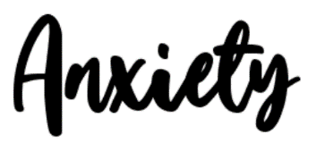

There are many unknowns at the moment, so many questions about the virus without any definite answers.
Uncertainty and unpredictability lead to fear, stress and anxiety. This can start to affect our mental and physical health.
Feeling fearful and anxious at a time such as this is normal and appropriate. Given the nature of the threat we are facing, fear and anxiety are natural responses as they alert us to the fact that we need to be taking action to look after ourselves and others.
It’s also important to recognise that if we are not careful fear and anxiety can quickly reach a tipping point, beyond which they can affect us in a negative way.
Many people at feeling the same way at the moment and reaching out to people will help you feel less alone.

Give yourself time and space to worry, you could use a form of expression (writing, art or talking) to let out these thoughts so that it doesn’t take over.
It is natural and normal to worry particularly in times of crisis. However this can get the better of all of us and if you feel your worry and anxiety if taking over, it may be time to try and take control.

.

- Stay away from the news
- Choose what to focus on
- Distract yourself
- Stay connected
- Practice mindfulness techniques

Stay away from the news
Constantly reading, watching or checking the news only makes your anxiety grown stronger.

Choose what you focus on
It’s a difficult time, because we’re isolated and many of us feel lonely and helpless. Instead of thinking about social isolation and the difficulties surrounding it, which can make us depressed, change your focus. Is there something you’ve always wanted to do but have never had the time – a project at home or a new skill or language you’ve always wanted to learn, maybe even British sign language.

Distract yourself
Our minds can’t hold two thoughts at once. We can’t panic about coronavirus and at the same time be absorbed by a work project. So next time a worrying thought creeps into your mind, try to distract yourself – it can be with work, taking a shower, or even watching a silly YouTube video.
Distraction is much more effective than trying to “not think” about something, because whenever we try to suppress thoughts, they come back to us– it simply doesn’t work.
Try this experiment: close your eyes and try to not think of a polar bear. Did it work? Of course not!
In order not to think about something, you have to conjure up an image of that thing in the first place. It’s the same with coronavirus or anything unpleasant you don’t want to think about. Telling yourself that you shouldn’t be thinking about something and trying to banish unwanted thoughts makes it even worse. Distraction is far more effective.

Stay connected
Even though we’re socially distancing ourselves from other people, this doesn’t mean that we should be socially isolating ourselves. Make use of technology and communicate with friends and family.
Reach out if you need help.

Remember: thoughts are mental events that will pass
Anxiety may get the better of you and you’re finding it hard to fall asleep at night or to concentrate during the day because of the uncertainties of the situation.
Our thoughts are mental events – any consuming thoughts you have now will pass just like many others did.

Taken from the University of Cambridge, Five ways to beat anxiety and take back control of your life during the OCID-19 pandemic-based on science.

Childline Tool Box has a calm zone where you can access activities, breathing exercises, yoga, games and videos on ways to cope and expressing emotionhttps://www.childline.org.uk/toolbox/calm-zone/?fbclid=IwAR2UDQqDr54URa1T6_pXFAJTxI3PpVt6dkR1dDHiyN4IrWpuocfTuRpUPQ8



If you have difficulty letting go of thoughts, consider practicing some mindfulness breathing techniques, meditation, talking, writing or simply moving.

Breathing exercise, practice breathing slowly through your nose and out slowly to calm down your nervousness. When you slow your breathing rate down the uncomfortable physical sensations of fear and anxiety start to subside.
Try the following –
Stop what you’re doing, take three long, slow deep breaths.
Create a rhythm on your breathing so that your out-breath becomes longer than your in-breath.
Try a 4-2-6 rhythm – e.g. breathe for 4 counts, hold your breath for 2 counts, and breathe out for 6 counts
If that doesn’t feel comfortable, try a 3-1-4 rhythm.
The main thing is that your out-breath is slightly longer than your in-breath.
Focus on your breaths going in and out of your lungs while gently letting go of thoughts.

Move
Any kind of movement is a great way of releasing the build –up of excess energy that accompanies anxiety. Go for a run, do some stretching, yoga or crank up some uplifting music and dance around the house
Meditation
Close your eyes for a few minutes each day and allow your mind and body to settle into stillness.
If thoughts arise just allow them to pass and draw your focus gently back to your breath.

Write your feelings down, keeping a journal can ease a troubled mind when you are not ready to talk about what is bothering you

.

Talk about your feelings, they can seem much worse in your head especially if you don’t talk about them and let them build up. Find someone you can trust.

Get colouring
There are lots of mindfulness drawings online.
So sharpen your colour pencils and start.
It will help to calm your mind as well as improve your attention span.



Contributing to the wellbeing of others helps shift our attention from ourselves onto what we can do for them. This helps us connect with other, even if only in a small way and positively impacts on our own wellbeing.
Doing good or altruism, put simply is when we put other people’s needs before our own. You might know this as random acts of kindness.
Evidence shows that helping others can have a positive effect on your own mental health and wellbeing. It reduces stress, improves mood, self-esteem and happiness.
There are many ways that you can help others as part of your everyday life, for example simply offering someone your seat on the bus.
However at the moment we are restricted to the space of our homes and the people that we are living with BUT this should not stop you from considering how you might help others at this difficult time.


Ask who would like a cup of tea
Teach someone in your family something new.
Do the washing up
Do some gardening
Hear a younger sibling read
Sort out old clothes or books for recycling to charity shop
Ask ‘how are you feeling?’
Look out for our 30 day wellbeing challenge

Get the hoover out
Play a game with younger siblings

Ring a friend or relative to check they are ok
Tidy your bedroom without being asked

Prepare the dinner


If you need to talk to someone at school please email
Childline  https://www.childline.org.uk/ |  |  |  | 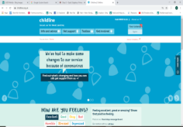
Young minds  https://youngminds.org.uk/ |  |  |  | 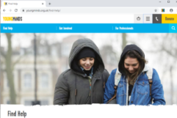
Anna Freud  https://www.annafreud.org/on-my-mind/youth-wellbeing/ |  |  |  | 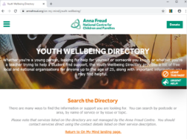
Bullying UK  https://www.bullying.co.uk/ |  |  |  | 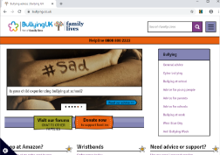
Healthy young minds  https://healthyyoungmindspennine.nhs.uk/ |  |  | 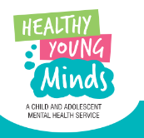 | 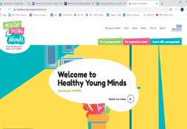
Hub of hope  https://hubofhope.co.uk/ | 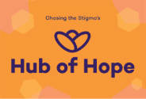 |  |  | 



