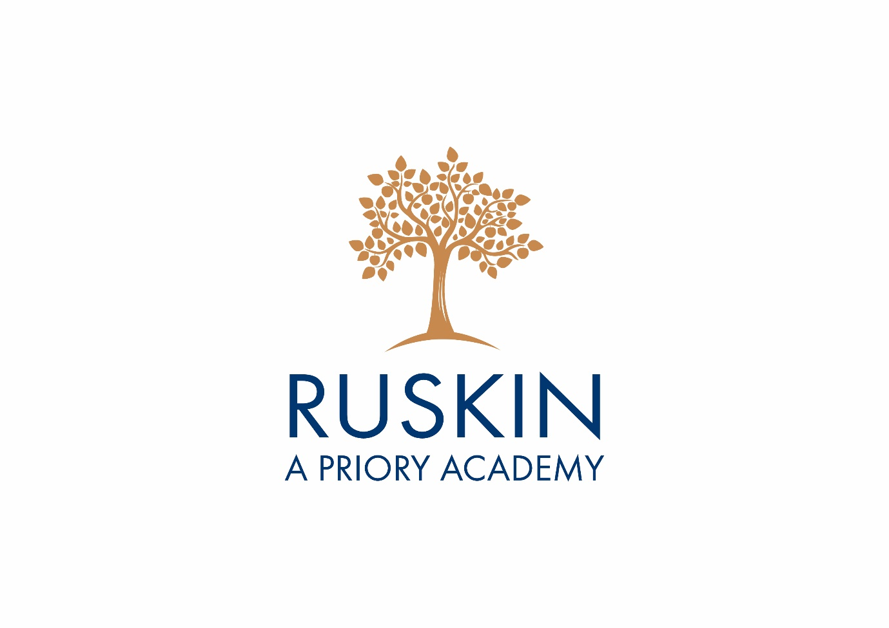
Ruskin Values
Year 11
Future Steps

Wisdom

Expand your Skills  Try the following FREE online courses to expand your skills set and show colleges, sixth forms and employers you have been working hard during the lockdown! | Completed
- Use the link below to access free learning from the Open University. Courses are either aimed at Level 1, 2 or 3. You will find a range of free online courses ranging from money and business to the arts and maths. Complete the course, and receive a free downloadable certificate.

www.open.edu/openlearn/free-courses/full-catalogue

- Explore the free online numeracy and digital courses available at:

https://theskillstoolkit.campaign.gov.uk

Look to your Future …

Explore future careers at :

www.nationalcareers.service.gov.uk

What interests you? What skills, qualifications and interests would help you achieve your goals? Create a plan.

Curiosity
Task | Completed
Critical Reflection Task.

Instructions:
- Go to www.16personalities.com, find the section on the Home page called:
What is your type?
Take our free personality test today!
- Click on “Take the Test”. Answer all 60 questions as honestly as possible about yourself. Don’t rush answering the questions, and equally, don’t get stuck on any – keep moving through at a steady pace.

- From the results page, take a note of your Personality Type (it will be four letters, eg ESTJ) and fill in below. You will need this for the workshop on Friday.

- Go to the “Type Description” for your profile and study carefully. Make a note below of a few aspects that you think are like you and one or two that aren’t like you.
- If you have time, go to “Career Paths” and take a note of possible careers that you might be interested in (if any), or aspects of work that might appeal to you.

- Personality Type, eg ESTJ, INFP
- Type Description – aspects of the profile that are like you (list a few items)

- Type description – aspects of the profile that are not like you
- Career paths – aspects of a job that are attractive to you
- Other observations

Take a Crash Course

The following YouTube channel has thousands of videos giving you a crash course in everything from Mythology to Chemistry, Film Production to statistics and everything in between

https://www.youtube.com/channel/UC-9-kyTW8ZkZNDHQJ6FgpwQ
Take a Virtual Field Trip

More than 2,500 museums around the world have made their collections accessible online through Google Arts and Culture; you can also take virtual tours of U.S national parks, the international space station and even the surface of Mars.

https://artsandculture.google.com/

Generosity
Task | Completed
Give to Others

Complete a ‘MyMarathon’. This is your marathon, your way. Challenge yourself to cover 26.2 miles in your own time, at your own pace, in a safe space and raise money for a good cause

https://www.bhf.org.uk/how-you-can-help/fundraise/mymarathon

or
‘Marathon 4 NHS’

Have a look at the information sent to you on email from Mr Gunter and set yourself the challenge of completing this

Home Help

Volunteer to help around the house. Clean your room, help in the garden, or learn home cooking skills and cater for your family.

Get in Touch

Is there someone in your life who you have lost contact with? Maybe a friend from primary school or a previous neighbour. This might be a great time to get in touch; send them a message to see how they are or write them a letter.

Courage
Task | Completed
Try something new that helps to promote Mindfulness:
Mindfulness Meditation:
https://www.youtube.com/watch?v=ZToicYcHIOU
Tai Chi:
https://www.youtube.com/watch?v=vHBR5MZmEsY

Watch something Different

https://www.whatsonstage.com/london-theatre/news/stage-shows-musicals-opera-free-stream-online_51198.html

Stage shows, musicals and opera you can watch online now for free.
Try an Andrew Lloyd Webber musical – go onto Youtube “The show must go on.”

Try a new Exercise

Download the downdog exercise app and try a free yoga, Zumba, HITT, barre or 7-minute workout class

https://www.downdogapp.com

Keep a journal to evidence what you have tried out and what your thoughts were. Have you been inspired to take up a new sport/exercise as a result?

Passion
Task | Completed
Reflect on your passions

Reflect on what you are passionate about.
Are there higher education courses or apprenticeships relating to your passion? Could this passion become your career? Complete some research

https://nationalcareers.service.gov.uk/

https://www.notgoingtouni.co.uk/

https://www.ucas.com

“Find a job you enjoy doing, and you will never have to work a day in your life.” Mark Twain

Teach Someone

Create a vlog about something your passionate about.

Listen to an Audio Book

https://stories.audible.com/discovery

Audible streams literature online. It is currently free to use during the school closures

